Autonomous Gore Pinecone Collector

Initial Design Report Template

Kyle Zarycki – Project Lead
Elijah Gernster – Project Administrator
Tyler Rottkamp – Budget Liaison
Siyu Yu – Computer Aided Engineering

Fall 2025-Spring 2026



Project Sponsor: W.L Gore
Faculty Advisor: Rodolfo Echavarria Solis/ Dante A Archangeli
Sponsor Mentor: Anthony El-Shamsi, Chase Patchak, Jorge Corrales
Instructor: David Willy

DISCLAIMER
This report was prepared by students as part of a university course requirement. While considerable effort has been put into the project, it is not the work of licensed engineers and has not undergone the extensive verification that is common in the profession. The information, data, conclusions, and content of this report should not be relied on or utilized without thorough, independent testing and verification. University faculty members may have been associated with this project as advisors, sponsors, or course instructors, but as such they are not responsible for the accuracy of results or conclusions.

EXECUTIVE SUMMARY
The Autonomous Pinecone Collector project focuses on designing and building a small robotic system that can pick up fallen pinecones from outdoor areas such as fields and forests. The goal of this project is to make the process of pinecone collection faster, easier, and safer by reducing the amount of manual work needed. Collecting pinecones by hand is time-consuming and sometimes dangerous on uneven ground. By developing a robot that can perform this task automatically, our team hopes to improve safety and efficiency while providing an example of how small-scale robotics can be used in outdoor environmental maintenance. This project combines design, mechanics, and control systems into one machine through collaboration between Mechanical Engineering (ME) and Electrical Engineering (EE) students.
The design concept is based on a mobile robot that can travel over rough and sloped terrain while collecting pinecones into an onboard storage bin. The front section of the robot includes a rotating roller or brush-style collector that directs pinecones toward the storage container as the robot moves forward. The frame is designed to be lightweight but strong enough to support all the mechanical and electrical components. The mobility system will be designed to maintain traction and stability even on uneven surfaces, using either large wheels or a tracked configuration. This setup will allow the robot to move smoothly through different types of outdoor terrain such as soil, grass, or gravel. The control system will be designed to operate remotely during testing and may later support semi-autonomous functions. The ME team is responsible for the frame, suspension, and collection mechanism, while the EE team focuses on sensors, control, and power management.
The robot is designed to be simple, easy to repair, and maintain. Each part of the system can be removed or replaced if something breaks or needs improvement. The storage basket is placed at the back of the robot, so pinecones can be emptied quickly after collection. Safety and reliability are important goals, as the robot should work outdoors for long periods without damage or failure. The team also aims to make the system easy to use so that anyone on the team can test and operate it safely. All main parts and wires will be protected to prevent damage from dust, dirt, or moisture.
At the time of writing this report, the project is still in the design and modeling stage. The team has completed concept generation, subsystem research, and design evaluation to compare different options for the collection mechanism, suspension, and mobility system. CAD models of the main structure have been developed, and the team is preparing to begin prototype fabrication in the following phase. Once the prototype is built, the group will perform field testing to check mobility, collection performance, and structural durability. Data collected during these tests will be used to improve the design and verify that the robot meets its main goals. The total budget for this project is $3,000, which will cover materials, prototyping, and testing expenses. Additional funding may be used for spare parts or replacement components if necessary. The final deliverables will include a fully functional prototype, a complete CAD design package, testing data, and a final report that documents the design process, calculations, and results. The project will serve as a valuable example of teamwork between engineering disciplines and demonstrate how mechanical and electrical systems can work together to solve a real-world problem.

TABLE OF CONTENTS
Contents
DISCLAIMER 1
EXECUTIVE SUMMARY 2
TABLE OF CONTENTS 3
1 BACKGROUND 1
1.1 Project Description 1
1.2 Deliverables 1
1.3 Success Metrics 1
2 REQUIREMENTS 2
2.1 Customer Requirements (CRs) 2
2.2 Engineering Requirements (ERs) 2
2.3 House of Quality (HoQ) 2
3 Research Within Your Design Space 3
3.1 Benchmarking 3
3.2 Literature Review 3
3.3 Mathematical Modeling 3
4 Design Concepts 4
4.1 Functional Decomposition 4
4.2 Concept Generation 4
4.3 Selection Criteria 4
4.4 Concept Selection 4
5 CONCLUSIONS 5
6 REFERENCES 6
7 APPENDICES 7
7.1 Appendix A: Descriptive Title 7
7.2 Appendix B: Descriptive Title 7

BACKGROUND
This chapter of the report discusses the initial importance and motivation of the project. It provides an overview of the Autonomous Pinecone Collector project sponsored by W. L. Gore & Associates, along with the project's scope, budget and fundraising, major deliverables, and the criteria used to assess project success.

Project Description
The Autonomous Pinecone Collector project aims to design and build a robot that can collect fallen pinecones across uneven terrain in Flagstaff, Arizona. The goal is to create a machine that travels safely, collects efficiently, and improves manual methods.
Manual collection is slow, tiring, and sometimes unsafe. Automating this process will make pinecone removal faster and easier while reducing effort for land maintenance. The project also provides hands-on experience in robotics and teamwork between Mechanical (ME) and Electrical Engineering (EE) students.
The robot uses a tracked or wheeled drive, a front-mounted roller driven by a 12 V DC gear motor, and an onboard bin for storage. Its 6063-T6 aluminum frame and coil-spring suspension balance strength, weight, and stability. Powered by a rechargeable battery and a microcontroller control system, it can operate both remotely and semi-autonomously.
The ME team focuses on the frame, drivetrain, and collection system, while the EE team develops sensors, control, and power.
The project has a total budget of $3,000, which covers materials, manufacturing, and documentation. This funding will be used for aluminum stock, motors, fasteners, batteries, control components, and testing materials. The team also plans to raise around $300 (10%) through NAU engineering resources or small sponsorships to cover unexpected costs such as spare parts or replacement sensors. Some electrical components will be supplied by the EE team to minimize expenses and improve integration. So far, the team has not encountered major cost overruns, and the current budget is sufficient to complete prototype fabrication and field testing.
The team has completed subsystem design and evaluation, confirming that the motor, frame, and suspension meet performance needs. The next step is prototype assembly and outdoor testing to ensure reliability and safety. By project completion, the team aims to deliver a fully functional and efficient prototype.

Deliverables
The major deliverables for the Autonomous Pinecone Collector project are aimed at fulfilling both course requirements and client expectations, while also supporting the engineering and testing needs of the design team. By the end of Spring 2026, the team will deliver a fully functional and field-tested pinecone collection robot capable of operating on uneven, outdoor terrain.
Accompanying this physical prototype will be a complete SolidWorks CAD model, including technical drawings for all major components and assemblies. To confirm the design’s structural integrity and performance, engineering analyses such as stress evaluation and torque calculations will be performed and documented. A detailed Bill of Materials (BOM) and cost breakdown will be provided, outlining all parts, materials, and manufacturing expenses.
In addition to the physical and digital deliverables, the team will prepare a final technical report describing the design process, test procedures, and results. The completed system will be demonstrated through a live field test and final presentation to showcase its performance and verify that it meets both academic and client expectations.

Success Metrics
The success of the Autonomous Pinecone Collector project will be determined through several key performance areas. The first metric is operational safety. The robot must be designed and tested to operate safely in outdoor environments without posing any risk to users, property, or the surrounding environment.
The second metric concerns collection performance and reliability. The machine should demonstrate effective pinecone collection and storage capabilities across uneven terrain, while maintaining smooth mobility and mechanical stability.
Another important measure of success is maintainability and repeatability. The system should be designed so that components can be easily replaced, and its assembly process can be repeated by future teams or users.
Budget control also defines project success. The final prototype must be completed within the $3,000 budget provided by the client, with all expenditures clearly documented.
Finally, the project will be considered successful if it upholds the engineering quality and innovation standards expected in senior capstone projects, providing a reliable, well-documented, and practical solution to the defined technical challenge.

REQUIREMENTS
This section lists what the customer needs from the autonomous pinecone collector (CRs), translates those needs into measurable engineering requirements (ERs) with targets and units, and provides a House of Quality (HoQ) that links CRs with ERs. It is important to note that the guidelines provided by our sponsor were somewhat vague, so the CRs were obtained from clarification with our sponsor, while the ERs are practical derivations of the CRs (and are therefore subject to change later in the project as our design evolves).

Customer Requirements (CRs)
CR-01 - Collect fallen pinecones effectively within a bounded area. “Effective” meaning meeting the pickup-rate target and operating with minimal human intervention.

CR-02 - Avoid jams and minimize non-pinecone debris intake. Collection/hopper system should shed unwanted debris if possible and avoid causing stoppages.

CR-03 - Operate on uneven yard/forest terrain without causing undue damage. Maintain mobility and low ground impact on slopes/roots.

CR-04 - Simple handling and maintenance by one person. Lift, empty, and basic service should be one-person tasks.

CR-05 - Safe around people and property. Include emergency stop, guarding, and conservative contact limits.

CR-06 - Clear a typical area on a single run. Practical runtime and quick turnaround for recharging.

CR-07 - Reasonable size/weight for storage and transport. Fit through a 36-in doorway and stay manageable.

CR-08 - Low noise / no emissions at point of use. Appropriate for yards and semi-public spaces.

CR-09 - Handle expected pinecone size range. Works with common Ponderosa/longleaf sizes.

CR-10 - Autonomous operation on yard/forest terrain. Navigate and collect with minimal supervision.

Engineering Requirements (ERs)
ID | Engineering Requirement | Target | Units
ER-01 | Pickup efficiency (cones collected ÷ visible cones in test plot) | ≥ 70 | % collected
ER-02 | Hopper volume (usable) | ≥ 2.0 | ft³
ER-03 | Jam rate during operation | ≤ 1 | jams/h
ER-04 | Terrain handling (sustained incline) | ≥ 30 | degree incline
ER-05 | System weight (ready-to-run) | ≤ 50 | lb
ER-06 | Runtime per charge (autonomous) | ≥ 1.5 | hours
ER-07 | Emergency stop response | ≤ .2 | seconds
Table 1. Engineering Requirements

House of Quality (HoQ)
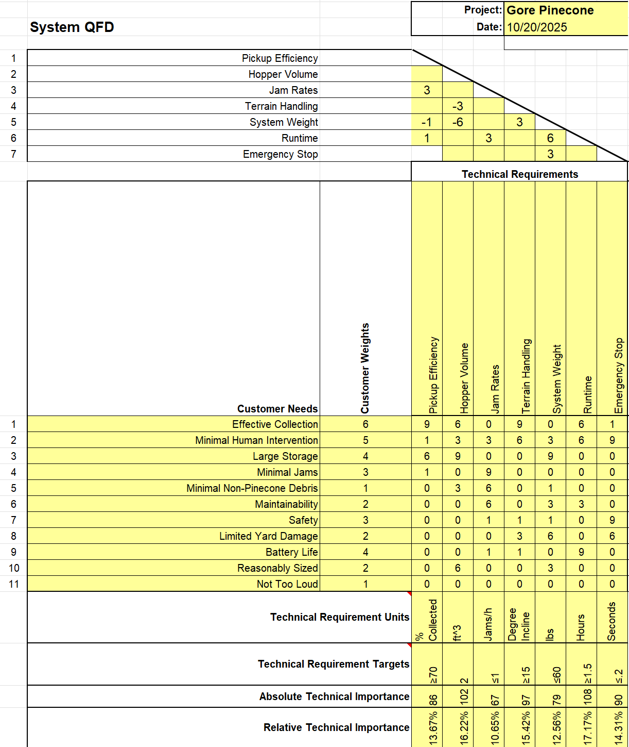
Figure 1. House of Quality

Research Within Your Design Space

Benchmarking
In this section, we cover the design benchmarks that our team has chosen to aim for. These marks were based off our subsystems and what we believed was state of the art in those fields. Firstly, for the collection system we chose to focus on a company called “Bag-A-Nut" [35]. This company makes a nut harvester and collection system that we believe can be applied to our project. The main idea of the design is a rolling wheel that can grab the nuts with outstretched appendages, then collect them in a hopper for storage. We believe this to be state of the art because it is the most simple and effective solution to our problem. The next benchmark we selected is related to our frame and track system. The design we decided to follow was the RUT capstone. This is due to Professor Reza being our capstone mentor and letting us view the project. We believe that building off what it did well, and improving what it did poorly will help our own project. The frame does a great job protecting the inner machinery and supporting the tracks, but it is heavy and expensive. However, we know that we can iterate this design and modify it to better suit our design. Finally, for the last major benchmark, we chose to focus more specifically on the suspension system. After some research our team discovered that a coil spring suspension system would fit our needs best like the one used in the “Dragon Runner Reconnaissance Robot” [19]. The reason this was chosen as a benchmark is because this system is great at absorbing shocks and keeping the system level. Without this, our design could potentially miss pinecones because of lifting off the ground or bouncing around too much. Using these major benchmarks as guides for our design will be incredibly helpful to our team and improve our final product greatly. Other sub-systems we focused on included our motor options. For the motors we needed something that would offer enough torque while also being easy to automate. Our group chose to use a standard 12V motor as the mark because it is readily available and will make for easy integration for our electrical engineering team. These are all the benchmarks chosen by the team; they were selected because they are the best option for each sub-system. With our team tailoring these designs to our project, we believe that they will improve our robot greatly.

Literature Review

Kyle Zarycki
[1] “Comparison of Multi-Tracked Running Gears in Terms of Obstacle Negotiation Capabilities”
This study examines multi tracked robotic platforms and concludes that adding additional tracks may increase terrain mobility but increases complexity and weight. The finding supports the teams decision to avoid multi-track arrangements.
[2] “Modeling, simulation, and experiments of a flexible track robot over rigid horizontal and inclined surfaces,”
Ezra investigates flexible track designs that can adjust to terrain sloped, reducing slip on offroad terrain. The article introduces adaptive belt tension control that demonstrate improved traction when compared to rigid systems. The results introduced suspension discussions.

[3] “An Instrumented Wheel-On-Limb System of Planetary Rovers for Wheel-Terrain Interactions: System Conception and Preliminary Design,”
Fengs work analyzes wheel terrain interactions showing the relationship between load distribution and traction lass. The article shows correlations between slip and ground pressure. This provides derivation for the track selection equations.
[4] “Experimental comparison of locomotion system performance of ground mobile robots in agricultural drawbar works,”
This research compares tracked and wheels mobility platforms and finds that tracks generally generate higher traction underload, but consume more power. Wheels however, are faster and more energy efficient. The trade off analysis influenced the teams choice to employ a tracked system.
[5]“The Challenges of Designing the Rocker-Bogie Suspension for the Mars Exploration Rover,”
This paper studies the rocker-bogie system found on NASA rovers. The paper explains how differential arm geometry preserves wheel contact over varying obstacles. While the system provides great terrain adaptability there are still issues found with the system. This article served as a high performance benchmark we could compare other systems too.
[6] “A Comparative Review of Omnidirectional Wheel Types for Mobile Robotics,”
The authors evaluate omnidirectional wheel systems for autonomous vehicles. They report superior maneuverability on hard surfaces but significantly reduced traction on soft or uneven ground. This guided the team to avoid omnidirectional wheels which primarily operates on forest floors.
[7]“J1269_201912: Rolling Resistance Measurement Procedure for Passenger Car, Light Truck, and Highway Truck and Bus Tires - SAE International,”
This Standard defines method for measuring rolling resistance and traction. It establishes the procedure used to find coefficients of traction (µ) and rolling resistance (Cᵣ), both of which were used in the team’s traction modeling and motor-torque calculations.
[8]“Rolling Resistance Coefficient for Real-World Roads” ResearchGate, 2021.
This data set compiles the empirical rolling resistance coefficients (Cr) for various surfaces, including asphalt, concrete, dirt, and more. The values were used to find the force required to prevent the system from rolling.
[9] R. G. Budynas, Shigley’s Mechanical Engineering Design, 11th ed., SI Units. New York: McGraw-Hill Education, 2020.
This textbook provides the foundational mechanical design equations applied in the spring and structural calculations. The text supplied formulas for static and fatigue loading of springs as well as supplying methods to validate components.

Elijah Gerstner
[10] "Frictional Properties of Red Pine Cones Harvested under Different Conditions"
This paper measures how surface texture, moisture, and contact material affect the friction of pinecones. It includes data on sliding resistance and how cone condition changes handling behavior. For our project, it helps estimate how pinecones will move along our collection surfaces and hopper. The friction data supports design choices for material selection and reducing jams in the pickup system.
[11] "Longleaf Pine Cone Collection on the Sabine National Forest"
This study reports real-world pinecone collection rates, area coverage, and methods used in a forest environment. It also discusses the challenges of gathering cones efficiently. We use this as a reference for realistic collection speeds and to compare our robot’s performance against manual collection. It helps set benchmarks for efficiency and hopper capacity.
[12] "Deep Learning Based Robot for Automatically Picking up Garbage on Grass"
This article describes a mobile robot that detects and collects trash on grassy terrain using a camera and deep-learning model. It shows how image recognition and path planning can work together. It relates to our project because pinecones, like trash items, are irregular in shape and rest unevenly on the ground. The methods in this paper guide how our sensors and software can detect and position for collection (If we take that route).
[13] "Forest Robot and Datasets for Biomass Collection"
This paper reviews forest robots and the datasets used for navigation and material collection. It focuses on unstructured outdoor environments with uneven ground and obstacles. The information is useful for our team because it outlines how robots can operate in forests similar to our test conditions.
[14] "Tracked Locomotion Systems for Ground Mobile Robots: A Review"
This review compares tracked robot designs and their advantages for off-road terrain. It includes details about traction, turning, and power efficiency on different surfaces. For our design, it helps justify our choice to use tracks instead of wheels. The article also helps guide suspension and power trade-offs for better stability and handling on forest or yard terrain.
[15] "Fully Autonomous Long Endurance Forest Rover"
This USDA project describes a self-operating rover that performs pine resin collection over long periods in the forest. It highlights endurance, navigation, and autonomous control. It connects to our work by showing a real example of an autonomous system working in similar terrain. It helps validate our approach to mobility, runtime, and autonomy goals.
[16] "Safety Requirements for Personal Care Robots" (ISO 13482:2014)
This standard outlines key safety features for robots that operate near people, including limits for speed, stopping time, and contact force. Even though our robot works outdoors, this helps us design safe operation standards. It supports design decisions like adding emergency stops, safe torque limits, and covers around moving parts.

Tyler Rottkamp:
[17] “Carbon Fiber vs. Aluminium vs. Steel: Which Chassis Material is Best?,”
This source was used to determine initial material options that should be considered for our framework. It offers an insight into the benefits of each choice; while also describing the cons that come with each. Through this source we narrowed the options down to the three choices described later.
[18] P. Fromaget, “Raspberry Pi vs Arduino: 7 Differences you Should Know,”
This comparison shows us what each device offers to our design. After looking into the benefits of both and discussing it with our electrical team, we decided using both would be the best choice for our design. This resource helped us come to this conclusion.
[19] “Dragon Runner Reconnaissance Robot,”
This paper was used as an early design benchmark because of the similar terrain it faced. This paper shaped how we designed our frame and tread attached to it.
[20] P. Deepa, P. Kartik, P. Jaiswal, and Y. Kanase, “Bomb Disposal Robot,”
A contrasting view on the previous idea, this was due to a different application. Helped the team get more design ideas, and do a pro/con comparison between the two.
[21] lukegarrigan, “Coding a Roomba - Codeheir,”
This source contains code for mapping and obstacle avoidance. Since our robot will require both, this was used as a benchmark for our code in the early stages of the project. Due to the electrical side taking over this aspect of the project, this will be the last we touch on code.
[22] Bastaki, “Drones and Robotics in Forestry: Applications and Innovations | Keshtezar,”
I chose to use this source because it did a great job outlining the purpose of robotics in forestry environments. This helped us make a smarter design because we learned more about the enviornmental factors that our robot will face. It also has a section that touches on autonomous harvesters, which was useful industry information.
[23] I. Kamal, “Small Robot Drive Trains,”
This paper was useful for designing our drive train because it offered examples of good systems, then talked about their performance. It also covered common design concerns that should be considered in every drive train system. With this reference, compiling our system becomes easier.
[24] “ASM Material Data Sheet,”
This was the material data sheet for Aluminum 6063-T6. It was used to find material constants for mathematical modeling.
[25] “ASM Material Data Sheet,”
Source 25 is the same as 24, but for Aluminum 6063-T5. Used for the same calculations.
[26] Andrew, “304 Stainless Steel Properties - Physical, Mechanical Properties,”
For the stainless steel, I had to use a different source because ASM did not have one for 304 specifically. However, this source had all the values I needed for the material selection calculations.
[27] “Aluminum 6063,”
This source is the general price of Aluminum 6063-T6 for different sizes. This is mostly for sheet metal, but they do offer piping on their website as well. Good as a comparison point to red rock manufacturing.

3.2.4 Siyu Yu
[28] McNulty, “A review of Li-ion batteries for autonomous mobile robots”, Elsevier, 2022.
This paper reviews different types of Li-ion batteries used in autonomous mobile robots. It helped our team understand the trade-offs between battery capacity, weight, and safety for our design. The information supports our decision to use a rechargeable Li-ion battery system for outdoor operation.
[29] Oliveira et al., “Advances in Forest Robotics: A State-of-the-Art Survey”, Machines, vol. 10, no. 2, 2021.
This paper reviews the latest developments in forest robotics, focusing on navigation, perception, locomotion, and energy systems used in unstructured outdoor environments. It helps our team understand the challenges robots face when operating on uneven forest terrain and supports our design decisions related to mobility, terrain adaptation, and power management.
[30] Xiao & Whittaker, “Energy Utilization and Energetic Estimation of Achievable Range for Wheeled Mobile Robots Operating on a Single BatteryDischarge”, Univ. of Texas Tech Report.
This technical report analyzes how wheeled mobile robots use energy and how to estimate their operating range under a single battery discharge. It provides useful methods for calculating power consumption and predicting runtime in different terrains. Our team used this resource to guide energy calculations and battery capacity decisions for the Pinecone Collector.
[31] Poskart, “Multi-Parameter Predictive Model of Mobile Robot’s Battery”, Sensors, 2022.
This paper presents a predictive model for estimating the performance and remaining energy of Li-ion batteries in mobile robots. It considers factors such as temperature, load, and discharge rate to improve energy estimation accuracy. The ideas in this paper help our team understand how to monitor battery health and manage power usage more efficiently in the Pinecone Collector.
[32] Li et al., “Localization in Unstructured Environments: Towards Autonomous Robots in Forests with Delaunay Triangulation”, arXiv preprint, 2020.
This paper presents a localization approach for autonomous robots operating in forests using Delaunay triangulation. The method builds a geometric map of the terrain from local features to estimate position without GPS. It helps our team understand how to improve navigation and positioning in outdoor environments for the Pinecone Collector.
[33] Pereira et al., “Robots for Forest Maintenance: Vision System for a Forestry Navigation Machine”, Int. Conf. Robotics in Forestry, 2024.
This conference paper describes a vision-based navigation system for forest maintenance robots. It uses cameras and deep-learning algorithms to detect obstacles and plan paths in complex forest environments. The research helps our team understand how camera-based sensing could be used in future versions of the Pinecone Collector to improve navigation and obstacle avoidance.
[34] Robotics in Forestry”, ResearchGate Survey Article, 2016.
This survey article reviews early developments in forestry robotics, including applications such as tree monitoring, debris removal, and automated harvesting. It also identifies key challenges such as rough terrain, weak GPS signals, and limited robot autonomy. This resource helps our team understand the overall background of forest robotics and how our Pinecone Collector fits within this growing research field.
[35] “36" Hickory Nut Picker-Upper - Bag-A-Nut,” Bag-A-Nut, Oct. 07, 2025.
This source was used to benchmark the collection system. It is the most universally used for “nut” collection, including pinecones. Was instrumental in designing our collection system.

Mathematical Modeling

Suspension Calculations – Kyle Zarycki
Governing Equations
The total system weight is given by:
W=mg
Where m is equal to the total mass of the vehicle in kilograms, and g is the gravitational acceleration 9.81m/s.
The weight per track is W/n, where n is the number of supporting track contact points.

Spring Force and Selection
Each suspension spring supports a portion of the total weight. The required static load per spring is
Fw=W/n
Where n is the total number of springs. A factor of safety was then applied to the result for a load bearing design.
Fs = FoS x Fw
The value of Fs could then be used to determine the required spring constant k.
K=Fs/x
X represents the maximum expected compression of the spring. This formula ensures that suspension can sustain impact or dynamic loads under fully loaded conditions.

Track Geometry
For a tracked configuration, the requires contact width is
$$b=\frac{W}{2P_{max}L}$$
And the total contact are of the track becomes
$$A_{track}=2bL$$
In these equations Pmax is equal to the allowable ground pressure in pascals, L is the length in contact with the ground in meters, and b is the track width. This ensures soil pressure remains below the threshold value to prevent sinking or excessive friction.

Traction
The traction force available at the ground interface is modeled as:
$$F_{tm}=μW$$
And the rolling resistance as:
$$F_{r}=C_{r}W$$
Where $μ$ is the coefficient of traction and Cr is the rolling resistance Coefficient [8]. For inclined terrain, the total resistive slope force is:
$$F_{slope}=Wsinθ+C_{r}cos$$
These parameters were used to find a force that would be needed to overcome slop resistance and surface drag at 30 degree inclines.

Motor Selection
Motor torque is derived from the traction force and roller radius:
$$T=F_{tm}*r_{w}$$
And the required power is:
$$P=F_{tm}*v$$

Engineering References.
Shigleys Mechanical Engineering Design [9] was used for load deflection and spring rate formulas, as well as deriving formulas for track and motor selection.

ResearchGate Data on Rolling Resistance [8] was used to obtain realistic coefficients for both Cr and Pmax for offroad conditions.

Calculation Results
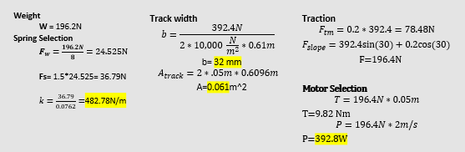
Figure. Suspension Engineering Calculations
Based on a robot that weighs approximately 20 kg, spring force, track width and required motor power were determined. The k value for each spring was calculated to be 482.78 N/m with a factor of safety of 1.5. The minimum Track width is 32mm and the required power to be supplied from the motor is 392.8 Watts.

Collection Sub-Assembly – Elijah Gerstner
Hopper Volume Calculations:
This set of equations is used to calculate an estimate of the hopper volume needed to store N number of pinecones. Final pinecone capacity will likely be determined by machine geometry, but this model allows us to predict how much space should be reserved for the hopper system while designing.
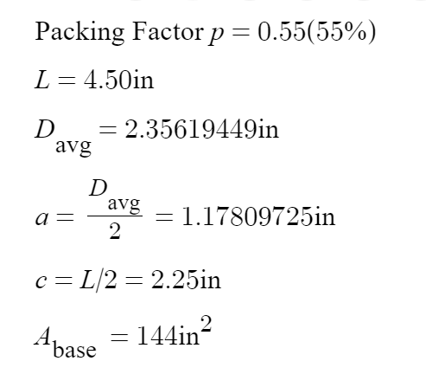
Figure. S
The given values are sourced from literature on the average size of Ponderosa pinecones; the packing factor is a general estimate for pinecones.

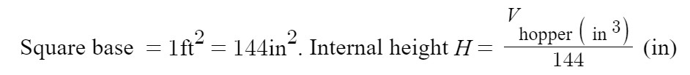
Figure. S
First, assume a square hopper with base measurements of 1x1ft, the height of the hopper will change with different values of N.

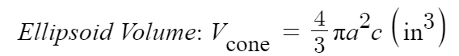
Figure. S
Second, approximate a pinecone as a prolate ellipsoid using average geometry.

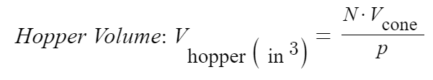
Figure. S
Third, insert previously calculated values and the N value of desired pinecones.

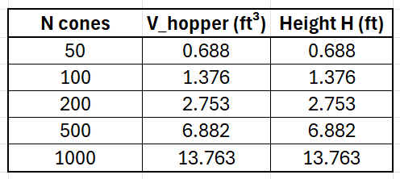
Table 2. Hopper Volume Table

Finally, this is a table of the resulting necessary volumes for 50-1000 pinecones.

Collection Prong Bending Force Calculations:

After settling on a prong-wheel design for the collection system, I assembled a set of equations that could be used to estimate the force required to bend a prong given its material, diameter, and length. Since multiple variations of prong diameter and length will be tested, this model is meant to provide guidance during prong material selection.

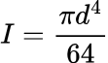Area Moment of Inertia (Circular), prerequisite equation.

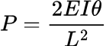Elastic Bending (Tip Rotation), prerequisite equation.

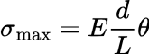Root Bending Stress, force needed for given parameters.

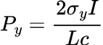Yield Force, to determine when a prong will permanently deform.

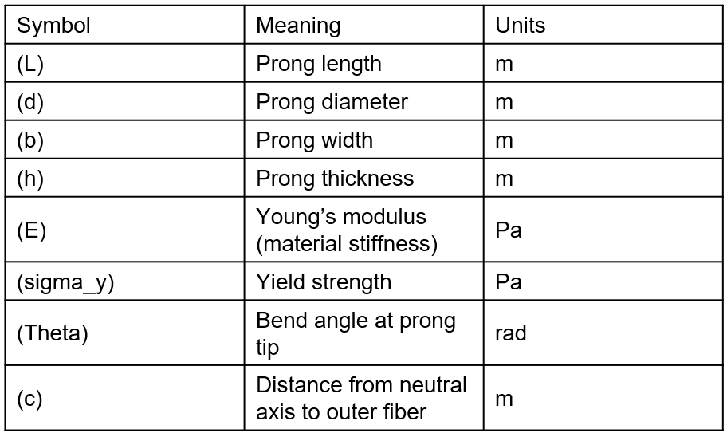
Table 3. Symbols with meaning and unit.

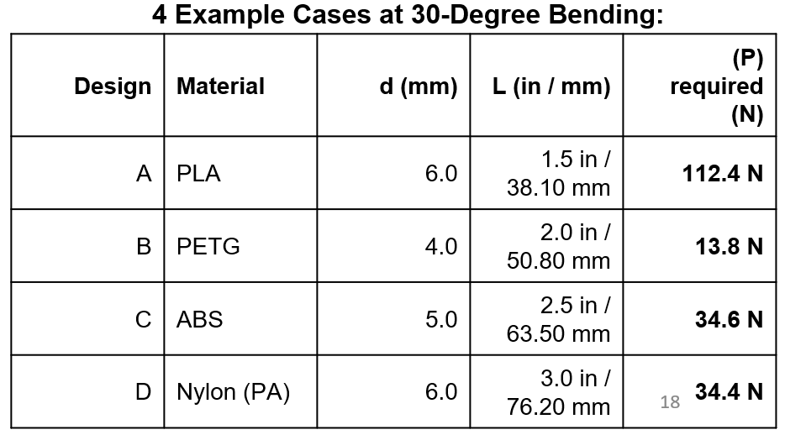
Table 4. force needed to impose a 30-degree bend on 4 possible example cases with varying material, diameter, and length.

Frame Calculations – Tyler Rottkamp
These calculations were done to determine which material would be the best for the frame. The three options that I chose were Aluminum 6063-T6, Aluminum 6063-T5, and 304 Stainless Steel. The reasoning behind these materials is they are all very corrosion resistant, and very widely used and machined metals. To determine which was the best choice, I found their material properties, expected weight for the design, and did an expected cost comparison. These steps are all shown below.
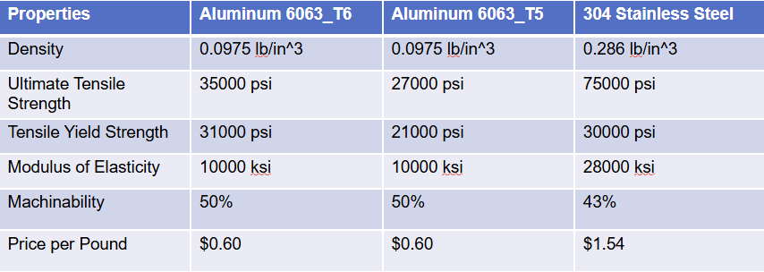
Table 5. Material Properties

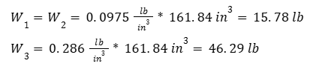
[x]:

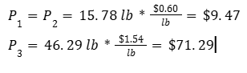
[x]:
Through these calculations, I was able to determine that Aluminum 6063-T6 is the best option for our project. This is because aluminum is cheaper and much lighter than stainless steel, for the T-5 and T-6 decision it came down to T-6 having higher ultimate and yield tensile strength. With these calculations we can move onto acquiring the material and getting it machined.
3.3.4 Motors’s calculations-Siyu Yu
The purpose of this section is to estimate the torque, angular velocity, and power required for the spike-wheel motor used in the Pinecone Collector. These calculations ensure that the selected motor provides sufficient performance under typical field conditions, including soil contact, roller acceleration, and load-bearing friction.

Governing Equations
The total load torque on the roller is the sum of the bearing friction torque, the ground contact torque, and the torque needed to accelerate the roller inertia. This relationship is given by
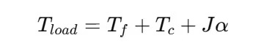

where Tf is the bearing friction torque (N·m), Tc is the ground contact torque (N·m), J is the roller’s rotational inertia (kg·m²), and α is the angular acceleration (rad/s²).
The torque required from the motor must account for the mechanical advantage of the gear system, the transmission efficiency, and a safety factor applied to ensure reliability. This is expressed as
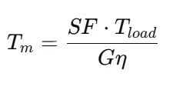
Where SF is the safety factor, G is the gear ratio, and η is the gear efficiency.
The angular velocity of the motor is related to the angular velocity of the roller by the gear ratio:
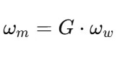
where ωw is the angular speed of the roller. The mechanical power required from the motor is then determined by the product of torque and angular speed:
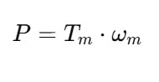
Where P is the mechanical power required from the motor (W), Tm is the torque at the motor shaft (N·m), and ωm is the motor’s angular speed (rad/s).

Parameter Definition and Assumptions
For the spike-wheel, the roller radius was assumed to be r=0.12 m, with a target ground speed of v=2.4 m/s,The acceleration time was taken as ta=0.25s. The gear ratio between the motor and the roller was selected as G=10:1 with an efficiency of η=0.8. The bearing-friction torque was estimated at Tf=0.1 N\m, and the torque due to ground-contact resistance was approximated as Tc=1.0 N\m. The roller rotational inertia was calculated as J=0.0015kg\m^2, and a safety factor of SF=2.0 was applied.
Calculation Results
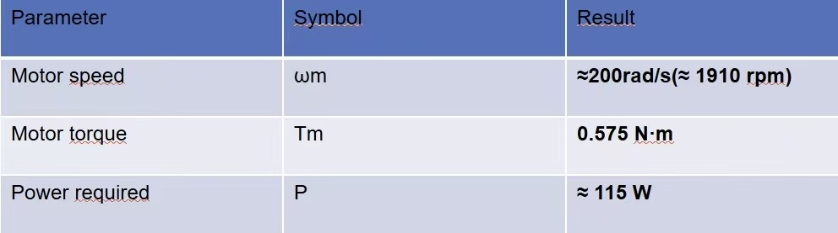

Discussion
Based on these calculations, the spike-wheel motor must be capable of delivering approximately 0.6 N·m torque at 1900 rpm, with an estimated power output of 115 W. Considering efficiency losses and terrain variations, a 12 V DC gear motor or NEMA 17 stepper motor provides sufficient performance and safety margin for continuous operation of the Pinecone Collector.

Design Concepts

Functional Decomposition
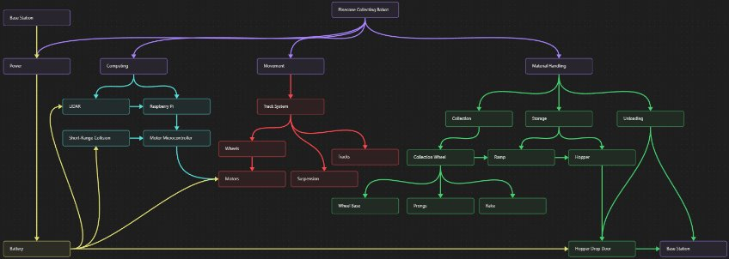
Figure 2. Functional Decomposition Chart
The functional decomposition chart, figure X, for the Gore Autonomous Pinecone Collector breaks the system into four primary subsystems. Power, Computing, Movement, and Material Handling. These functions represent what is required for the robot to successfully collect, store, and unload pinecones autonomously. Of the four systems, Movement and Material Handling were specifically focused on since they are the mechanical operations of the robot.

Movement
The Movement subsystem enables the robot to traverse through rough terrain effectively. This subsystem includes the track system, suspension system, and motors. These elements work together to provide traction and stability as the robot moves over uneven ground. The designs generated optimize this system for performance ensuring the robot can operate in forest environments while maintaining collection operation.

Material Handling
The Material Handling subsystem is responsible for the collection, storing, and unloading of pinecones. This system includes the collection wheel, prongs, hopper, drop door, and frame. The designs generated for this system were created to effectively gather pinecones, temporarily store them on the robot, transport them, and dump them at the base station. This subsystem is the most critical part of the project's overall success and represents the main innovation of the project.

Importance
The functional decomposition is important to this project because it defines the core operations of the pinecone collecting robot. It provides a structured understanding of what goes into making each subsystem successful as well as ensuring each system integrates seamlessly. This structured approach also helps the efficiency of the team by allowing for task delegation and reducing design overlap. Ultimately, this decomposition ensures the robots development is organized so the team can focus more time on testing and validation.

Concept Generation
The top-level design consists of 4 systems. Suspension, motor selection, frame structure, and the collection mechanism. The following sections summarize the concept generation process for each system.

Suspension System
Four suspension concepts were considered for the project. These include, the rigid track system, vertical volute spring suspension, coil spring suspension, and the rocker-bogie suspension. The rigid track system (Figure 3.) offered simplicity and durability but lacks adaptability on uneven terrain. The vertical volute spring suspension (Figure 4.) provides a compact and robust suspension orientation but is mechanically complex at the smaller scales. The rocker-bogie suspension configuration (Figure 6.) has excellent terrain adaptability but lacks shock absorption as well as introducing steering complexity since it consists of a wheeled system. The coil spring suspension system (Figure 5.) demonstrates the best balance between simplicity and performance but introduces periodic spring maintenance.
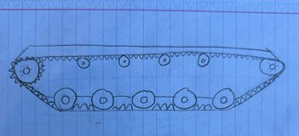  Figure 3. Rigid Track System | 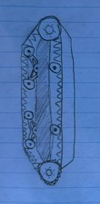  Figure 4. Vertical Volute Spring Suspension
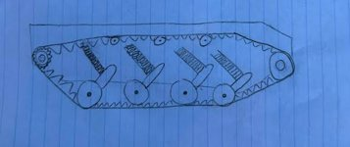  Figure 5. Coil Spring Suspension | 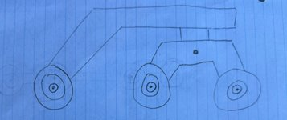  Figure 6. Rocker Bogie Suspension System

Motor Selection
Three motor concepts were generated for driving the autonomous robot. These consist of the DC motor, Stepper motors, and Brushless DC motors. The DC motor (Figure 7.) offers simplicity, low cost, and high starting torque however DC motors suffer low efficiency as well as increased wear due to the brush used in the motors. The stepper motor (Figure 8.) provides high precision but wouldn’t be able to supply the required torque under load. The brushless DC motor (Figure 9.) provides the best efficiency and lifespan with the downsides of an increased price.
  Figure 7. DC motor | 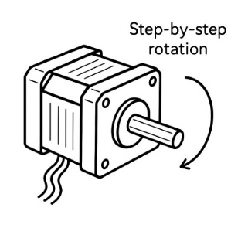  Figure 8. Stepper Motor

Figure 9. Brushless DC motor

Frame Structure
Four frame concepts were developed during concept generation. The first concept was to use a lightweight pipe frame as seen in Figure 10. This concept offered minimal cost but insufficient rigidity. The second concept also used a lightweight pipe frame while adding sheet metal for protection as seen in Figure 11. This design improved protection but introduced mounting issues as well as introducing flooding issues in wet environments. The third concept introduces a two level frame (Figure 12.) that is similar to concept one. This provides more stability than concept one but doubles the weight of the frame. The fourth and final concept consists of a sheet metal body with pipes as reinforcements, as seen in Figure 13. This maximizes protection but compromises collection accessibility since this system would put the collector roller in the back.
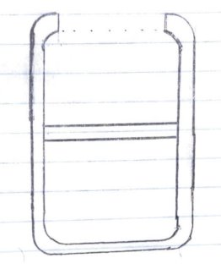  Figure 10. Lightweight Pipe Frame | 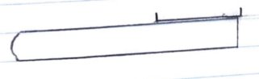  Figure 11. Pipe Frame with Sheetmetal base
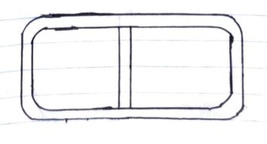  Figure 12. Two level Pipe Frame | 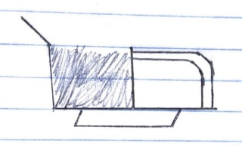  Figure 13. Sheet metal and Pipe Combination

Collection Mechanism
Three types of mechanisms were considered when generating concepts for the collection system. The first being the wire cage as seen in Figure 14. The wire cage is a low-cost collection system that is currently used to pick up objects like tennis balls. This system performs well at picking up spherical objects and preventing the captured objects from falling out, but performs poorly with the varying shape of pinecones. The second design consists of multiple discs to collect pinecones as seen in figure 15. This design offers simplicity and rigidity but limits he range of collectible object sizes. The final mechanism uses prongs to either pierce pinecones or lodge pinecones prongs. This system has already been proven to work with pinecones and allows for further innovation, however due to the number of prongs the manufacturing complexity increases drastically when compared to the other systems.
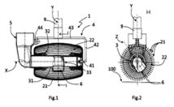  Figure 14. Wire Cage | 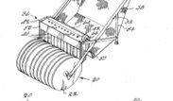  Figure 15. Disc Collection
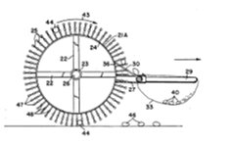
Figure 16. Prong Collection

Selection Criteria
Concept selection for each subsystem was based on quantifiable engineering requirements derived from the project’s objectives. Each criteria was evaluating performance estimations calculated from a combination of analytical calculations and manufacturer specifications. The selection process is summarized below.

Suspension Criteria
Criteria | Quantification | Requirement Source
Terrain adaptability | Maintain stability on a slope ≤ 30 ° | Engineering Requirement #4
Spring Stress | Be able to withstand > 1.5 times the weight under full load | Functional need to maintain terrain adaptability
Weight | ≤ 5 lbs per side | Engineering Requirement #5
Table 6.Suspension Criteria
Based on this Criteria six topics were created to evaluate the suspension system. These six topics were Simplicity, terrain mobility, cost, durability, weight, and ease of installment. Each of these topics come from a combinations of criteria.

Motor Criteria
Criteria | Quantification
Required Torque | Treq> 20Nm including a FoS of 2
Required Speed | > 3 miles per hour
Power Output | > 500 W including a Fos of 2
Efficiency | η ≥ 0.75
Table 7.Motor Criteria
The values for the motor criteria are based on require torque calculation performed at the systems worst case scenario (30 degree icy conditions). Based on this criteria five topics were created to evaluate the motor selection process. This includes meets torque and speed requirements, high runtime (efficiency), low cost, robust, and smooth operation. With torque and speed requirements being weighted the highest since those must follow calculated values.

Frame Criteria
Criteria | Quantification
Material Strength | > 30,000 psi
Weight | < 20lbs total frame weight
Corrosion Resistance | Must withstand outdoor moisture
Table 8.Frame Criteria
The values for the frame criteria come from data tables that give strength and weight of aluminum. Based on this criteria, not only could a material be selected to make the frame, but also the frame designs could be evaluated. The frame designs were evaluated based on ease of collection system integration, collision resistance, cost, Structural integrity, and overall weight.

Collection System Criteria
Criteria | Quantification
Capture Effectiveness | >= 70% retrieval
Prong yield force | >20 N
Weight | <5 lb assembly
Table 9.Collection Criteria
Based on this criteria, the material of the collection system could be selected. Once a material was selected the different concepts could be evaluated. Each concept was evaluated by its effectiveness, manufacturability, cost and durability.

Concept Selection
Concept evaluation was completed by using Pugh charts for all mechanical subsystems. Baseline concepts were chosen from low-cost configurations (e.g Rigid suspension) for comparison. The concepts that met engineering requirements were scored with a weighted decision matrix. The concept with the highest score would be then selected for that subsystem. Once a concept from each subsystem was chosen, they were brought together to make a final CAD model.

Suspension Selection
Criterion​ | Weight​  ​ | Rigid​ | VVSS​ | Coil Spring​ | Rocker Bogie​
Simplicity​ | 2​ | 5​ | -2​ | -1​ | -2​
Terrain mobility​ | 3​ | 2​ | +1​ | +2​ | +2​
Cost​ | 3​ | 5​ | -2​ | -1​ | -2​
Durability​ | 2​ | 2​ | -1​ | +2​ | -1​
Weight​ | 1​ | 5​ | -2​ | -1​ | -1​
Ease of instalment​ | 1​ | 5​ | -2​ | -1​ | -3​
Table 10. Suspension Pugh chart
The rigid track system was used as a baseline to compare the other systems to because it consisted of the simplest assembly. The other systems were then compared to the rigid system on a plus minus scale. Based on the scores, the coil spring system was chosen because it achieves excellent mobility without sacrificing too much manufacturability or durability.

Drive Motor Selection
Criterion​ | Weight​  ​ | DC Gearmotor​ | Stepper​ | BLDC​
Meets torque & speed​ | 0.3​ | 5​ | 4​ | 5​
Efficiency / runtime​ | 0.2​ | 3​ | 2​ | 5​
Control & cost simplicity​ | 0.25​ | 5​ | 3​ | 2​
Robustness / maintenance​ | 0.15​ | 4​ | 3​ | 5​
Noise / smoothness​ | 0.1​ | 3​ | 3​ | 5​
Weighted score​ | 1​ | 4.3​ | 3.2​ | 4​
Table 11. Motor Selection Pugh Chart
Each motor was scored on the weighted pugh chart. Based on the weighted score values, a DC gear motor was selected because of the simplicity and ability to meet torque requirements.

Frame Selection
During the frame selection process a material was first selected before scoring each frame concept. The material selected was Aluminum 6063 T6.
Criterion​ | Weight​ | Concept 1​ | Concept 2​ | Concept 3​ | Concept 4​
Easy Collection Integration​ | 0.25​ | 4​ | 4​ | 4​ | 2​
Collision Resistance​ | 0.25​ | 2​ | 3​ | 5​ | 4​
Cost​ | 0.20​ | 5​ | 4​ | 3​ | 4​
Structural Integrity​ | 0.15​ | 2​ | 3​ | 5​ | 4​
Weight​ | 0.15​ | 5​ | 5​ | 4​ | 4​
Weighted score​ | 1​ | 3.55​ | 3.75​ | 4.2​ | 3.5​
Table 12. Frame Pugh Chart
Based on the frame selection Pugh chart, the two level aluminum frame was selected. This was due to the practical mounting application and overall integrity.

Collection Mechanism Selection
The collection selection process was different than the other subsystems due to the different components that make up the system. There are three different parts that make up this system. The capture tool, which consists of how pinecones are attached to the collection system. The rake, which is the part that disconnects the pinecones and guides them to the storage system. And the structure, which consists of how the collection wheel is supported. Each part was scored on its effectiveness, manufacturability, cos and durability. Table . shows the results of these scores.
​ | 1​ | 2​ | 3​ | 4​ | 5​ | 6​
Capture​ | 4.5​ | 5.2​ | 8.6​ | 7.5​ | 6.3​ | 7.0​
Rake​ | 7.2​ | 8.4​ | 6.8​ | ​ | ​ | ​
Structure​ | 9.1​ | 6.2​ | 8.5​ | 6.8​ | ​ | ​
Table 13. Collection Mechanism Pugh Chart
Based on the results a capture, rake, and structure were selected to create a final collection mechanism.

Final CAD model
The initial CAD model for the Autonomous Pinecone Collector represents what all of the selected subsystems would look like together. While this design may differ from the final product, it is still important to serve as a visual aid of how the systems work together.
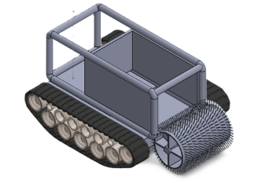
Figure 17. Final Cad Model

CONCLUSIONS
In conclusion, this project asks us to create an autonomous vehicle that can collect pinecones more efficiently than a human can. The main design requirements we want to reach are that it will be fully autonomous, efficient, capable of covering normal Flagstaff terrain, quiet, environmentally safe, and easy to use. After listing these requirements, our team began designing our project. To come up with informed designs, we did extensive research into benchmarks that we should aim to exceed. These were very helpful in creating the best prototype for our application because we could incorporate state-of-the-art sub-systems. Next, we needed to use mathematical modelling to determine the pros and cons of these benchmarks and find the required inputs. These calculations helped us make informed design choices such as motor selection, materials selection, track width, and collection system volume. With these calculations done, we were able to go into concept generation and the selection process. In this section, each team member was responsible for generating four designs for their sub-system. Then, we found which design was the best by doing more calculations and using design matrices. After this, we were able to compile these into one design, which is our first prototype. We will continue to use this design method to iterate on our prototype until we reach our desired final product. For the future, our team believes that we need to focus on prototype construction and meeting with our mentors for more guidance. With our next steps laid out, we hope to make good progress on prototyping by presentation three. This timeline keeps us on schedule and will ensure enough time to iterate the design process. To summarize, this report covers our methods up until this point, and the steps that we need to take in the future if we want to succeed.

REFERENCES
[1]D. Szpaczyńska, M. Przybysz, and Tomasz Muszyński, “Comparison of Multi-Tracked Running Gears in Terms of Obstacle Negotiation Capabilities,” Applied Sciences, vol. 15, no. 4, pp. 1696–1696, Feb. 2025, doi: https://doi.org/10.3390/app15041696.​
[2] N. Ezra, A. Cohen, and D. Zarrouk, “Modeling, simulation, and experiments of a flexible track robot over rigid horizontal and inclined surfaces,” Mechanism and Machine Theory, vol. 199, pp. 105689–105689, May 2024, doi: https://doi.org/10.1016/j.mechmachtheory.2024.105689.​
[3]L. Feng, X. Jiang, and A. Song, “An Instrumented Wheel-On-Limb System of Planetary Rovers for Wheel-Terrain Interactions: System Conception and Preliminary Design,” arXiv (Cornell University), pp. 96–101, Mar. 2022, doi: https://doi.org/10.1145/3529261.3529278.​
[4]S. M. Shafaei and H. Mousazadeh, “Experimental comparison of locomotion system performance of ground mobile robots in agricultural drawbar works,” Smart Agricultural Technology, vol. 3, p. 100131, Feb. 2023, doi: https://doi.org/10.1016/j.atech.2022.100131.​
‌[5]B. D. Harrington and C. Voorhees, “The Challenges of Designing the Rocker-Bogie Suspension for the Mars Exploration Rover,” 37th Aerospace Mechanisms Symposium, May 2004. http://ntrs.nasa.gov/citations/20040084284? (accessed Sep. 17, 2025).​
[6]H. A. Almusawi and Hussam Akkad, “A Comparative Review of Omnidirectional Wheel Types for Mobile Robotics,” Aug. 06, 2023. https://www.researchgate.net/publication/372941239_A_Comparative_Review_of_Omnidirectional_Wheel_Types_for_Mobile_Robotics
[7]“J1269_201912: Rolling Resistance Measurement Procedure for Passenger Car, Light Truck, and Highway Truck and Bus Tires - SAE International,” Sae.org, 2019. https://www.sae.org/standards/content/j1269_201912/ (accessed Sep. 19, 2025).
[8]“Rolling resistance coefficient for real world roads,” ResearchGate, 2021. https://www.researchgate.net/figure/Rolling-resistance-coefficient-for-real-world-roads-13_tbl2_351973711​
[9]Budynas, Shigley’s Mechanical Engineering Design, 11Th Edition, Si Units. S.L.: Mcgraw-Hill Education (As, 2020.

[10] Y. Ren, C. Teng, T. Gao, Y. Zhang, H. Liu, and X. Dong, “Frictional properties of red pine cones harvested under different conditions,” BioResources, vol. 19, no. 1, pp. 766–788, Dec. 2023, doi: https://doi.org/10.15376/biores.19.1.766-788.
[11] G. F. Weick, E. B. Jackson, R. Smith, J. Crooks, B. Crane, and J. M. Guldin, “Longleaf Pine Cone Collection on the Sabine National Forest during October 2014,” Journal of Forestry, vol. 115, no. 3, pp. 238–241, Jul. 2016, doi: https://doi.org/10.5849/jof.15-145.
[12] J. Bai, S. Lian, Z. Liu, K. Wang, and D. Liu, “Deep Learning Based Robot for Automatically Picking Up Garbage on the Grass,” IEEE Transactions on Consumer Electronics, vol. 64, no. 3, pp. 382–389, Aug. 2018, doi: https://doi.org/10.1109/TCE.2018.2859629.
[13] R. Reis, Santos, and L. Santos, “Forest Robot and Datasets for Biomass Collection,” Advances in intelligent systems and computing, pp. 152–163, Nov. 2019, doi: https://doi.org/10.1007/978-3-030-35990-4_13.
[14] L. Bruzzone, S. E. Nodehi, and P. Fanghella, “Tracked Locomotion Systems for Ground Mobile Robots: A Review,” Machines, vol. 10, no. 8, p. 648, Aug. 2022, doi: https://doi.org/10.3390/machines10080648.
[15] “An Unmannd Fully Autonomous Long Endurance Forest Rover for Automated Pine Resin Collection - B & L NAVAL STORES, INC.,” Usda.gov, 2019. https://portal.nifa.usda.gov/web/crisprojectpages/1019669-an-unmannd-fully-autonomous-long-endurance-forest-rover-for-automated-pine-resin-collection.html (accessed Sep. 17, 2025).
[16] “Robots and robotic devices -Safety requirements for personal care robots.” Available: https://cdn.standards.iteh.ai/samples/53820/5ddca453a6d141e5a558f4f791ea3229/ISO-13482-2014.pdf”
[17] “Carbon Fiber vs. Aluminium vs. Steel: Which Chassis Material is Best?,” NitPro Composites, 2025. https://www.nitprocomposites.com/blog/carbon-fiber-vs-aluminium-vs-steel
[18] P. Fromaget, “Raspberry Pi vs Arduino: 7 Differences you Should Know,” Raspberry tips. https://raspberrytips.com/raspberry-pi-vs-arduino/
[19] “Dragon Runner Reconnaissance Robot,” Army Technology. https://www.army-technology.com/projects/dragonrunnerrobots/?cf-view
[20] P. Deepa, P. Kartik, P. Jaiswal, and Y. Kanase, “Bomb Disposal Robot,” International Journal of Current Science, vol. 14, no. 2, pp. 2250–1770, 2024, Available: https://rjpn.org/ijcspub/papers/IJCSP24B1087.pdf
[21] lukegarrigan, “Coding a Roomba - Codeheir,” Codeheir, Oct. 16, 2021. https://codeheir.com/2021/10/16/coding-a-roomba/ (accessed Sep. 10, 2025).
[22] Bastaki, “Drones and Robotics in Forestry: Applications and Innovations | Keshtezar,” Keshtezar.com, 2025. https://keshtezar.com/blog/posts/drones-and-robotics-in-forestry-applications-and-innovations/ (accessed Sep. 10, 2025).
[23] I. Kamal, “Small Robot Drive Trains,” Feb. 2008. Accessed: Sep. 11, 2025. [Online]. Available: https://www.idc-online.com/technical_references/pdfs/electronic_engineering/Small_Robot_Drive_Trains.pdf
[24] “ASM Material Data Sheet,” asm.matweb.com. https://asm.matweb.com/search/SpecificMaterial.asp?bassnum=MA6063T5
[25] “ASM Material Data Sheet,” asm.matweb.com. https://asm.matweb.com/search/SpecificMaterial.asp?bassnum=MA6063T6
[26] Andrew, “304 Stainless Steel Properties - Physical, Mechanical Properties,” 304 Stainless Steel. https://304stainlesssteel.org/304-stainless-steel-properties/#google_vignette
[27] “Aluminum 6063,” iScrap App, Feb. 28, 2025. https://iscrapapp.com/metals/aluminum-6063/

APPENDICES
[Use Appendices to include lengthy technical details or other content that would otherwise break up the text of the main body of the report.]

Appendix A: Descriptive Title

Appendix B: Descriptive Title

